Data sets

Data source: FAO STAT Crops and livestock products

1. **Beehive number**

<https://www.fao.org/faostat/en/#data/QCL>

1. Search: “Bees”
2. Click on Crops and livestock products (Production)
3. Choose countries: from the Americas (Argentina, Mexico, Brazil, Canada, Uruguay, Chile and Cuba) and from the Eastern hemisphere (China, India, Viet Nam, Ukraine, Thailand, Taiwan and Turkey)
4. Choose Element: Stocks
5. Choose Item: Live Animals. Then select Bees
6. Choose Years: Select All
7. Click: Download data
8. **Honey Export Quantity[1]\***

<https://www.fao.org/faostat/en/#data/TCL>

1. Search: “Natural honey”
2. Click on Crops and livestock products (Trade)
3. Choose countries: 7 from the Americas (Argentina, Mexico, Brazil, Canada, Uruguay, Chile and Cuba) and 7 from the Eastern hemisphere (China, India, Viet Nam, Ukraine, Thailand, Taiwan and Turkey)
4. Choose Element: Export quantity
5. Choose Item: Crops and Livestock products. Click on > for dropdown list. Then select Natural honey
6. Choose Years: Select All
7. Click: Download data
8. **Honey Export Value\***

<https://www.fao.org/faostat/en/#data/TCL>

1. Search: “Natural honey”
2. Click on Crops and livestock products (Trade)
3. Choose countries: 7 from the Americas (Argentina, Mexico, Brazil, Canada, Uruguay, Chile and Cuba) and 7 from the Eastern hemisphere (China, India, Viet Nam, Ukraine, Thailand, Taiwan and Turkey)
4. Choose Element: Export value
5. Choose Item: Crops and Livestock products. Click on > for dropdown list. Then select Natural honey
6. Choose Years: Select All
7. Click: Download data

Data source: WITS (World Integrated Trade solution)

1. **Swiss Import quantity (of natural honey)**

<https://wits.worldbank.org/trade/comtrade/en/country/CHE/year/1988/tradeflow/Imports/partner/ALL/product/040900>

1. Select “Switzerland Natural honey imports by country in 1988”
2. Download in Excel

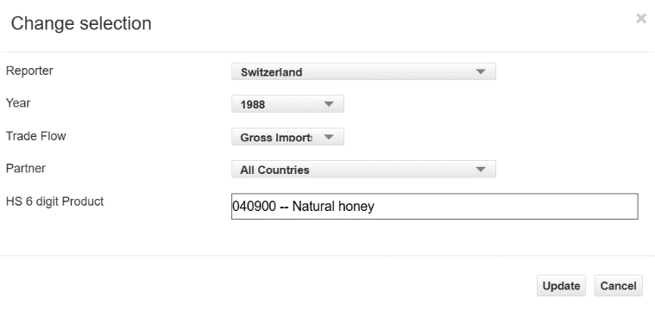Repeat this process for every year until 2023, and then combine Excel files.

The downloaded data provide Trade value in USD and quantity in Kg.

Select data (where available) for the countries of interest: from the Americas (Argentina, Mexico, Brazil, Canada, Uruguay, Chile and Cuba) and from the Eastern hemisphere (China, India, Viet Nam, Ukraine, Thailand, Taiwan and Turkey)

1. *I would download export quantity and value separately because if you download them together the layout in the Excel file looks complicated.